GRADITELJSKA, PRIRODOSLOVNA I RUDARSKA ŠKOLA, VARAŽDIN
„MILCO“ d.o.o., Varaždin

BUSINESS PLAN
Introduction of a new product „Yogochest“ and manufacturing assortment expansion of MILCO food industry

Neven Novak, Antonia Talaš, Manuela Kamenić, Ilija Kubat, Borna Novosel, Anamaria Benčić, Karla Ciglarić, Ana-Maria Čretni, Tea Dokleja, Roman Hosni, Tena Zavrtnik
Varaždin, February, 2018.

CONTENT
 |  |  | page
1. | Summary ............................................................................................................ |  | 3
2. | Description of the entrepreneurial idea ............................................................ |  | 3
3. | Market exploration ............................................................................................ |  | 4
 | 3.1. | Graphical representation of questionnaire ............................................ | 5
4. | Swot analysis ...................................................................................................... |  | 8
 | 4.1. | Identification of strengths, weaknesses, opportunities & threats ........ | 9
 | 4.2. | Ranking according to importance and probability of occurrence ........... | 9
 | 4.3. | Analysis of the relationship between the opportunity with strengths and weaknesses, and threats with strengths and weaknesses ............... | 11
5. | Marketing ........................................................................................................... |  | 12
 | 5.1. | Marketing mix (4p) ................................................................................. | 12
6. | Production organisation ..................................................................................... |  | 14
 | 6.1. | Production scheme ................................................................................. | 15
7. | Financial analysis ................................................................................................ |  | 16
 | 7.1. | Monthly analysis ..................................................................................... | 17
 | 7.2. | Annual analysis ........................................................................................ | 18
8. | Conclusion .......................................................................................................... |  | 20
9. | Literature ............................................................................................................ |  | 20

- SUMMARY
Business plan is a written document describing goals of a business undertaking, and the manner in which those goals are achieved. After we had been acquainted with the project we tried to find our perfect product. This was the hardest part, as we needed to come up with something new and eye catching.
After a lot of contemplating, arguing and research we managed to come up with an idea: chestnut puree yogurt. Later we divided our crew into 3 teams: Marketing, Finance and one team to explore the market. Our marketing team had its mission: the name of our product, logo, packaging, advertisements and our vision for the team.
As expected, each participant had a different idea and it was very hard to find the best one for the product and us as a company. Finance had a simple but a tough problem to solve; to determine the approximate costs and profits that the product could bring us. The team that was instructed to investigate the market did just that with a SWOT analysis alongside. We hope that this product will be successful and that it will bring a considerable profit to the company.

- DESCRIPTION OF THE ENTREPRENEURIAL IDEA

We are Milco™, a dietary company specialised in dairy products. We are a Croatian company, from Varaždin located in its industrial area. Currently we are a small company with only 150 workers, but big plans for the future.
Our newest product (chestnut puree yogurt with cloves, cinnamon and honey) is one of the more risky products with the surveys of mostly mixed results, but we are facing the risk with our heads raised high. Our targeted consumers are all age groups except infants, e.g. not intended for toddlers. Our primary competitors are „Vindija“ (Croatia), „Dukat“ (Croatia), „Milla“ ( Italy), „Danone“ (France), „Zott“ (Germany), „TINE“ ( Norway), „Mimosa“ (Portugal).
For our supply of raw materials we mostly chose local suppliers for the honey, chestnut, milk and packaging „Straža plastika“ , but our supplier of spices is „Kotanyi“ (Austria). Our source of financing is a loan of 250 000 kn which is nearly 34 000 euro, which we intend to pay back within 2 years.
- MARKET EXPLORATION
By careful selection of product name and ingredients (chestnut yogurt) we were ready to investigate the field and our competition. Firstly, we set out to check our own country's companies that specialize in dairy products or more specifically yogurts. The more recognizable and bigger corporations such as „Vindija“, „Dukat“ and „Kim“, as expected, produced a lot of different flavours of yogurt but thankfully none produced our kind.
Going home and getting on the computer we went on the Internet and continued our search there. As we first investigated our home country's companies we confirmed our results in the shops, then we continued and translated the name and ingredients into three languages we needed to research. We searched for the product in Portuguese, Italian and Norwegian and unexpectedly found a match. An Italian dairy company has already made and sells chestnut yogurt. After a thorough consideration and failed prototypes we finally changed the recipe, packaging and the name.
45 people of different age and sex were examined.
Questionnaire
Introducing a new nutritional product "yogurt with chestnut puree" in the production assortment of ''MILCO'' foodstuffs.
General information (circle):
AGE: <18 18-25 25-45 >45
SEX: M F
The following questions apply to the new product, and please circle what you think is based on your eating habits:
1.Do you like yogurt?
YES NO
2.How often do you consume yogurt?
1 (every day) 2 (once a week) 3 (once a month) 4 (rarely)
3.Do you like chestnut puree?
YES NO
4.How often do you consume chestnut puree?
1 (every day) 2 (once a month) 3 (once a year) 4 (rarely)
5.Do you like combination of yogurt and chestnut puree with the addition of cinnamon?
YES NO
6.Would you try this yogurt?
YES NO
7.Do you like the product name, “YOGOCHEST''?
YES NO
8.Do you think that such a product would be successful?
YES NO
9.How often would you buy this yogurt?
1 (every day) 2 (once a year) 3 (once a month) 4 (rarely)
10.Do you consider that such a product would have a high level of competition?
YES NO



The results shown in the table:
 | 1 | 2 | 3 | 4 | YES | NO
1. |  |  |  |  | 39 | 6
2. | 6 | 24 | 8 | 7
3. |  |  |  |  | 27 | 18
4. | 0 | 5 | 20 | 20
5. |  |  |  |  | 25 | 20
6, |  |  |  |  | 38 | 7
7. |  |  |  |  | 41 | 4
8. |  |  |  |  | 31 | 14
9. | 2 | 9 | 18 | 16
10. |  |  |  |  | 24 | 21

  - GRAPHICAL REPRESENTATION OF A QUESTIONNAIRE

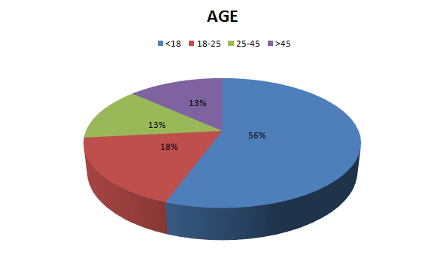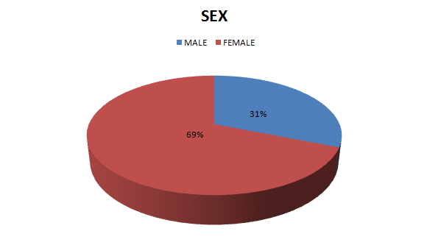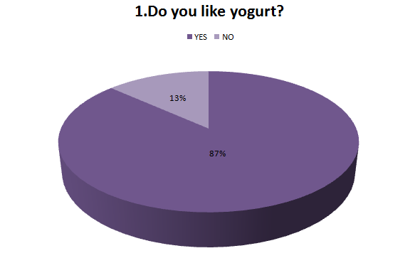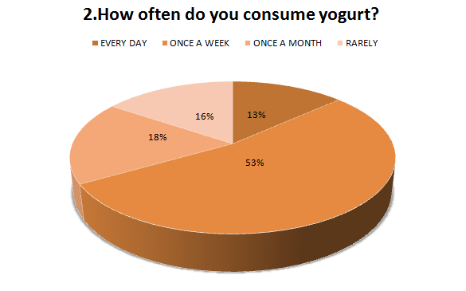
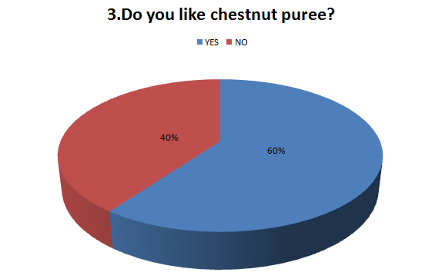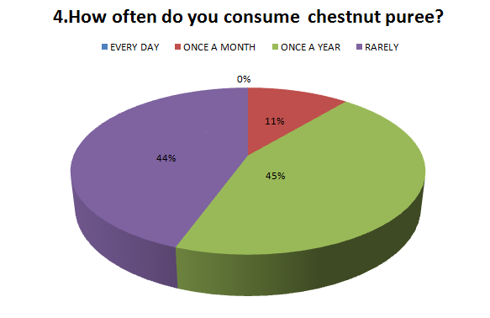
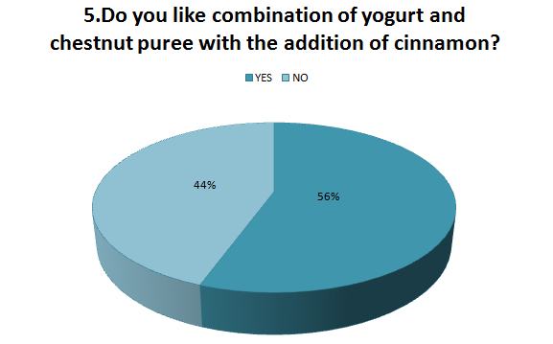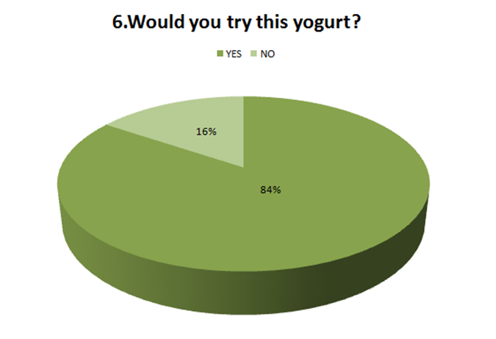

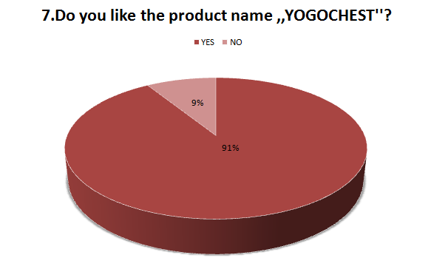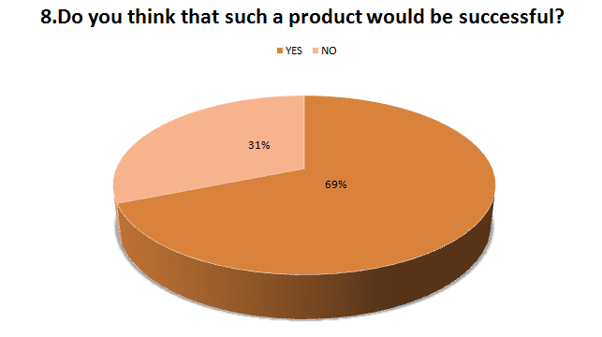
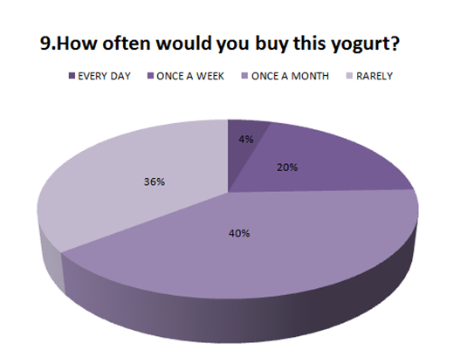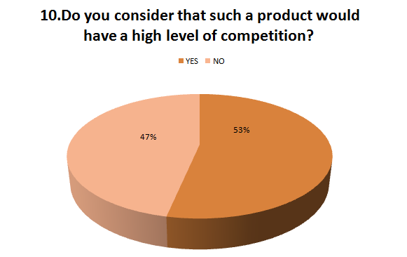

During the survey we turned more to young people because we think that our future lies with them.
Most people like yogurt and most eat it at least once per week, which is a good prospect for our product.
Only 10% more people love Chestnut puree and consume it rarely so we will try to raise the consumption of this product to the consumption of 86% of people.
We were not sure if people would fancy the name *YOHOCHEST* for our product so we asked them and most people liked it.
It is believed that the product would be successful, people would buy it at least once per month and probably have a big competition but with good raw materials and advertisements would make our product competitive in the market

- SWOT ANALYSIS
Swot analysis presents an important link in the analytical process of each project as it provides information about the organization and the project team. This analytical method is often applied due to its simplicity that enables good strategic planning of project development and organization themselves.
SWOT analysis is characterized by two perspectives: organizational, conditioned in present and past time, and the prospects of the environment focused on the future. The name itself is the acronym of English phrases.
Strengths
Weaknesses
Opportunities
Threats
Benefits of SWOT analysis
The key element of the formulation option is to harmonize organizational strengths and weaknesses with the opportunities and threats that exist on the market. When properly used, SWOT analysis can provide good basis for formulating the strategy. SWOT analysis is widely recognized in marketing and management literature as a systematic way to achieve the goal.
Disadvantages of SWOT analysis
According to Mintzberg (1994) SWOT is a little effective method because it is rooted in the current perception of the organization. In practice, this is often an activity that is not being implemented well. After identifying all important points, it is not known what to do with the generated data. Regarding the use of information generated to implement strategies, the SWOT analysis is not prescriptive.
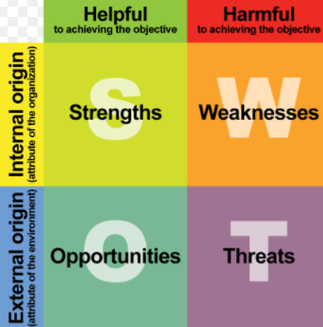
  - IDENTIFICATION OF STRENGTHS, WEAKNESSES, OPPORTUNITIES & THREATS

STRENGTHS & WEAKNESSES
- the strengths of companies are identified in the form of what the company possesses and potentially leads to increased competitiveness and must be based on facts.
- Strengths and weaknesses are tangible (equipment, buildings, etc.) and inexhaustible (organizational culture, strategies, etc.) of the company's resources, SWOT analysis does not contain all the features of the company, but only those that relate to the key success factors.
OPPORTUNITIES & THREATS
- They are developed as a consequence of the global environment (legal, political, technical-technological, economic, social and societal influences)
- Threats are all situations that are unfavourable for the enterprise and which can endanger and slow down the achievement of organizational goals and endanger the future of the enterprise, wheareas opportunities are the main favourable situations in the business environment. The purpose of the analysis is to force the manager to anticipate important events that could affect the company
STRENGTHS  S₁- high nutritional composition  S₂- product quality  S₃- originality | WEAKNESSES  W₁ - weak financial situation  W₂ -short shelf life
OPPORTUNITIES  0₁ ₋ increase in demand for the product  0₂ - new ways of packaging  0₃ - favourable market trends | THREATS  T₁ - unfavourable economic situation  T₂ - the appearance of competition

  - RANKING ACCORDING TO IMPORTANCE AND PROBABILITY OF OCCURRENCE
Ranking depends on specific forces, weaknesses, opportunities and threats, where their ranking has the role of reflection on possible further procedures.
STRENGHTS
2x (S₂)
1x (S₁)
 | S₁ | S₂ | S₃
S₁ | - | S₂ | S₁
S₂ | - |  | S₂
S₃ | - | - | -

OPPORTUNITIES
2x (O₃ )
1x (O₂ )
 | O₁ | O₂ | O₃
O₁ | - | O₂ | O₃
O₂ | - | - | O₃
O₃ | - | - | -

WEAKNESS
 | W₁ | W₂
W₁ | - | W₁
W₂ | - | -
1x(W₁)

THREATS

 | T₁ | T₂
T₁ | - | T₂
T₂ | - | -
1x(T₂)

  - ANALYSIS OF THE RELATIONSHIP BETWEEN THE OPPORTUNITY WITH STRENGTHS AND WEAKNESSES, AND THREATS WITH STRENGHTS AND WEAKNESSES

In this step, it is necessary to identify strengths, weaknesses, opportunities and threats by recognizing which forces can be affected by the reduction of certain weaknesses, that is, which opportunities can be used to address specific threats. By some power we can affect more weakness or more strength can affect some weakness.

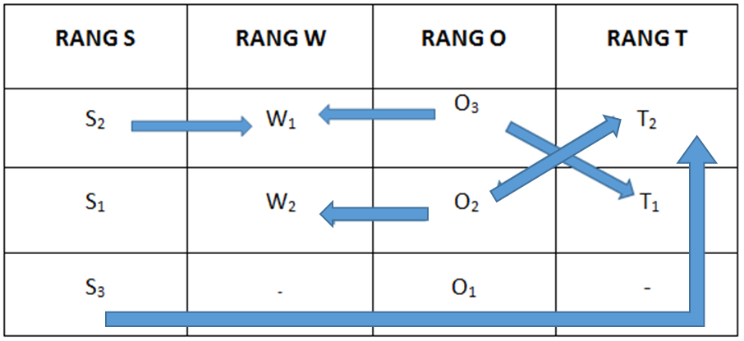

(W₁, S_{2,} O₃) – weak financial situation- product quality, favourable market trends
- We can fix our company’s weak financial situations with high product quality and favourable market trends
(W₂, O₂) – short shelf life – new ways of packaging
- With new ways of modern packaging we can prolong our short shelf life of product.
(T₁, O₃ ) – unfavourable economic situation - favourable market trends
- The problem of unfavourable economic situation can be improved by favourable market trends
(O_{2,} S₃, T₂,) – The appearance of competition – new ways of packaging, originality
- The appearance of competition can be solved with new modern ways of packaging and originality of product

- MARKETING
GOAL
Our goal of marketing our product is to manage future, predictable events with desire to achieve the best possible result and minimize unwanted business outcomes.
MISSION AND VISION
The mission and foundation of mere existence of our company is to improve life quality of our customers and to promote healthy life. Our company is manufacturing milk products, which are focused on health of our customers.
Mission: ˝One yogurt a day keeps doctor away˝
Vision: ˝One Yogochest a day equals better day˝
  - MARKETING MIX (4P)
PRODUCT:
Yogurt is packed in plastic bottles, net mass 200g. The wrap around the bottle contains pictures of ingredients used in the product. The combination of colours used for decorations is a mixture of blue and red.
Packing:
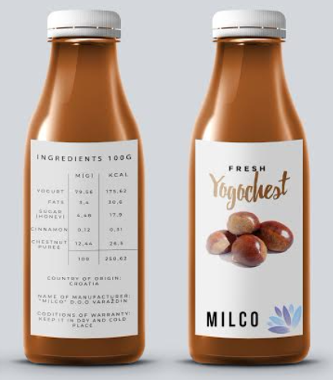

Declaration:
INGREDIENTS 100g | m (g) | kcal
Yogurt | 79,56 | 175,62
Fats | 3,4 | 30,6
Sugar (honey) | 4,48 | 17,9
Cinnamon | 0,12 | 0,31
Chestnut puree | 12,44 | 26,5
TOTALL | 100 | 250,62
COUNTRY OF ORIGIN: Croatia
NAME OF MANUFACTURER:˝MILCO˝d.o.o., Varaždin
CONDITIONS OF WARRANTY: keep in dry and cold place

PRICE
The promotion price of our product is 9kn (1,21€)
PROMOTION:
Free degustation on stands in shops will be used as a test for quality of our product that will be put on market. Product will be presented by video advertising.



PLACE (DISTRIBUTION):
Channels of distribution would be shops, bakeries, and some smaller shops. Means of transport used for this product need to be with special devices in order to contain the product unchanged.
- PRODUCTION ORGANISATION
The research and analysis, which were conducted, gave us more than satisfying results and helped us greatly with further processes and further realization of our business idea. Thus, a well-organised production process is initiated in order to produce optimal product with optimal features through minimal costs.
Solely safe and healthy ingredients will be used; raw cow milk pasteurised for about 10 minutes on temperature of 75°C (pasteurization is a thermal treatment which is conducted at temperatures between 55°C and 75°C, it kills microorganisms and inactivates enzymes in food), in addition to a microorganism culture, fermented at 40°C for about 12 hours.
After the fermentation, the milk is cooled and a fermented milk base is added followed by homogenisation of the product. Furthermore, ingredients necessary for achieving taste, smell and other features of the final product are added. That includes chestnut puree (manufacturer: Ledo), chestnut honey, ground cinnamon (manufacturer: Kotanyi), rum-sugar (manufacturer: Podravka). Milk is obtained from a farm in the surroundings of Varaždin.
In the end the mixture is chilled and packed in adequate packaging. The product is stored in appropriate conditions.
The experimental process of chestnut puree yogurt production has been conducted in laboratories of our school, Graditeljska, prirodoslovna i rudarska škola Varaždin.
Product recipe :
RECIPE | MASS (g) | MASS FRACTION (%)
Milk | 500 | 82.96
Chesnut puree | 75 | 12.44
Chesnut honey | 23 | 3.82
Milled cinnamon | 0.75 | 0.12
Rum sugar | 4 | 0.66
IN TOTAL | 602.75 | 100
The number of needed workers and structures are: one technologist and five workers. Number of working hours per day is 8 h, per week is 40 h and per month is 176 h. Investors are: bank (credit) and own resources.

  - PRODUCTION SCHEME
The production scheme shows the basic processes in the production of yogurt: pasteurization, fermentation, optimising ingredients (Chestnut puree and honey, cinnamon, rum-sugar).

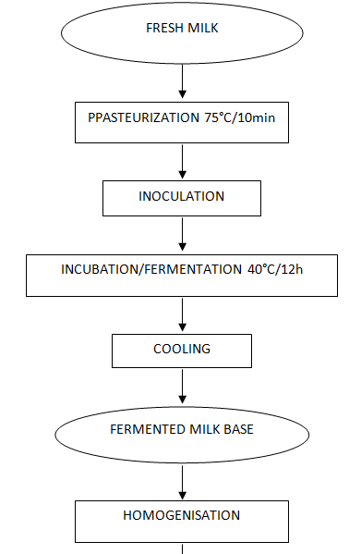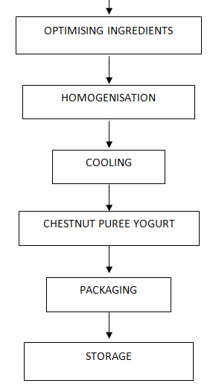

Scheme: Production scheme

- FINANCIAL ANALYSIS
Financial analysis is an important tool that a financial manager uses when deciding on business operations. Financial analysis indicators are the numbers which when put in a relationship of a certain size show the success of a business. The quantity of product produced at 8 hours is 2863. The daily cost of production is 7996,86 kn. After we had made calculations shown in the table, we came to the price of the product, which amounts to 10,56 kn or 1,41 €.

Calculation of production costs:
Costs | Price | Quantity | Amount
Raw materials | kn / kg | kg | kn | €
milk | 2,2 | 500 | 1100
chestnut puree | 35 | 75 | 2625
chestnut honey | 25 | 23 | 575
milled cinnamon | 110 | 0,75 | 82,5
rum sugar | 140 | 4 | 560
in total |  | 602,75 | 4942,5 | 659
loss (5%) |  | 30,1375
IN TOTAL |  | 572,6125
net mass (kg/pack) |  | 0,2
amount of products (pack) |  | 2863,0625
amount of products (pack) |  | 2863
Energy | kn / h | h | kn | €
water | 0,45 | 8 | 3,6 | 0,48
electricity | 1,62 | 8 | 12,96 | 1,728
Work force | kn / h* worker | worker | kn | €
worker | 25 | 5 | 1000 | 133,3333
technologist | 40 | 1 | 320 | 42,66667
Packaging | kn / pack | pack | kn | €
foil | 0,15 | 2863 | 429,45 | 57,26
plastic | 0,45 | 2863 | 1288,35 | 171,78
IN TOTAL |  | 2863 | 7996,86 | 1066,248
 | kn / pack | increase | kn / pack | € / pack
PRODUCER PRICE | 2,793174991 | 1,4 | 3,910444988 | 0,521393
WHOLESALE PRICE |  | 1,8 | 7,038800978 | 0,938507
RETAIL PRICE |  | 1,5 | 10,55820147 | 1,40776

  - MONTHLY ANALYSIS
Work days: 22
Daily costs: 7996,86kn
Daily production: 2863 p
Wholesale price: 7,04kn/p
Monthly production:
22 days * 2863 p = 62986 p
Expenses (monthly costs):
22 days * 7996,86 kn/day = 175930,92kn
Revenues:
62986 p * 7,04kn/p = 443421,44kn

After the monthly cost calculation it is obvious that during the first two months we work with a loss. In the first month we work with a – 262074,92 kn (-34943.3226 €) and in second month with -16584,40 kn (-2211,25333 €) cost. But in the other two we already work with profit; in the third month we will work with 228906,12 kn (30520,816 €) and in the fourth month we will work with 474396,64 kn (63252,88533 €) of profit. We can see that annual profits increase from year to year.

Monthly profit display:

 | 1. | 2. | 3. | 4.
INITIAL INVESTMENT (credit) | 250000,00
REVENUES | 185856,00 | 443421,44 | 443421,44 | 443421,44
EXPENSES | 175930,92 | 175930,92 | 175930,92 | 175930,92
CREDIT RATES | 22000,00 | 22000 | 22000 | 22000
PROFIT (kn) | -262074,92 | -16584,40 | 228906,12 | 474396,64
EURO(€) | -34943,32267 | -2211,253333 | 30520,816 | 63252,88533

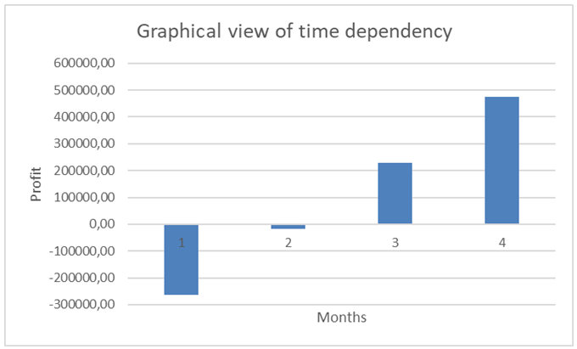

  - ANNUAL ANALYSIS
Work days: 256
Yearly vacation: 20 days
Daily costs: 7996,86 kn
Daily production: 2863 p
Wholesale price: 7,04 kn/p
Annual production:
256 days *2863p = 732928 p
Expenses (monthly costs):
256 days * 7996,86kn = 2047196,16 kn
Revenues:
732928 p *7,04 kn/p = 5159813,12kn

Annual profit display:
 | 1. | 2. | 3. | 4.
INITIAL INVESTMENT (kn) | 250000,00
REVENUES (kn) | 5063491,84 | 5321057,28 | 5321057,28 | 5321057,28
EXPENSES (kn) | 2111171,04 | 2111171,04 | 2111171,04 | 2111171,04
CREDIT RATES | 264000 | 264000
PROFIT | 2438320,80 | 2945886,24 | 3209886,24 | 3209886,24
PROFIT TAX ( 20 % ) | 487664,16 | 589177,248 | 641977,248 | 641977,248
NET PROFIT (kn) | 1950656,64 | 2356708,99 | 2567908,99 | 2567908,99
EURO(€) | 260087,552 | 314227,8656 | 342387,8656 | 342387,8656

- CONCLUSION
After the overall market research had been conducted we realized that the product did not exist in the market and we started planning a business plan. We surveyed the market and received positive responses that motivated us for further work. We conducted a SWOT analysis in which we used the positive side (strengths and opportunities) to solve the problems of the negative side (weaknesses and threats).
By calculating the cost of production of energy, packaging and labour inputs, we calculated the price of the product, which is 10.56 kn (1.41 €).
By developing marketing tactics (marketing mix), we have created a form of packaging and declaration. The mission and vision as well as the promotional price (€ 1.21) helped us to enter the market and attract new customers.
With a detailed financial analysis we can conclude that we already work with a 3-monthly profit. Annual analysis shows us that with continuous quality work we can succeed!

- LITERATURE
- Marušić, M., Vranešević, T.: Istraživanje tržišta, Adeco, Zagreb, 2001.
- Rječnik marketinga, Masmedia, Zagreb, 1993.
- Dobrović, Ž: Metamodeliranje – Osnovni koncepti strateškog plana; Fakultet organizacije i informatike Varaždin, 2008,
- Renko , N., Strategije marketinga, Naklada Ljevak, Zagreb, 2005.
- Previšić, J., Ozretić Došen, Đ.: Marketing, Adverta, Zagreb, 2004.
- Senečić, J.:Osnove marketinga, Mikrorad, Zagreb, 2000.
- Jalšić, V.:, diploma paper „Optimising ingredients of probiotic dairy desserts with chestnut puree“, Osijek, 2011.

